Scrum Master Report - Sprint 2 (Bachu Dhyaneswar)

Team:
1.Bachu Dhyaneswar
2.Hetvi Dharshandia
3.Aishwarya Kakde
4.Urvish Bhaliya
5.Shivam Pathak
6.Deepak

Team and Sprint Goals:
The primary objective of Sprint 2 is to complete and deliver the user-facing features required for the MCQ Assessment workflow. This includes designing and implementing the interface components necessary for students to take assessments and review their results.

Key Sprint Goals:
1.Design and Develop the Results Page
Ensure users can view their assessment outcomes clearly with a clean and intuitive UI.

2.Design MCQ Quiz Interface
Build a user-friendly and responsive layout enabling seamless navigation through questions.

3.Create MCQ Assessment Page
Implement the assessment page where users can view and attempt multiple-choice questions.

4.Results Page Enhancements and Implementation
Finalize result page features including score display, feedback layout, and UI polish.

Responsibilities and Action
- As the Scrum Master for Sprint 2, my responsibilities were focused on enabling smooth execution of the sprint goals and ensuring the team followed Scrum practices effectively.

- Facilitated all scrum ceremonies including Sprint Planning, Standups ensuring they were productive and time-boxed.
- Helped the team break down and clarify user stories related to:
Results Page Design
MCQ Quiz Interface Design
MCQ Assessment Page Creation
Results Page Creation
- Actively monitored sprint progress and maintained visibility through updates in the tracking board.
- Ensured any blockers or dependencies were identified and resolved quickly.
- Collaborated closely with the Product Owner to refine requirements and ensure acceptance criteria were well-defined for the Results Page features.
- Encouraged team collaboration and supported knowledge sharing across development and design tasks.

Team Contribution:
Hetvi, Aishwarya ->Research questions for MCQ Assessment
Deepak ->Design MCQ Quiz Interface
Bachu Dhyaneswar ->Create MCQ Assessment Page, Download results as PDF
Shivam ->Design Results page
Urvish → Create Result Page and MCQ Assessment Page

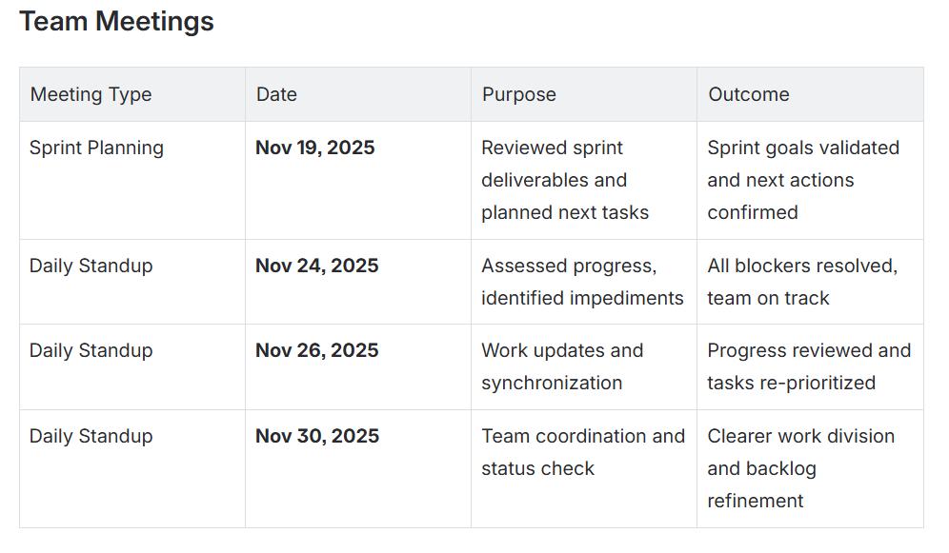

Reflection on Learning:
During Sprint 2, I enhanced my practical understanding of the Scrum framework through real-time application with the development team. Facilitating ceremonies helped me strengthen my skills in guiding discussions, time-boxing meetings, and ensuring alignment with sprint goals.

I learned the importance of effective communication in keeping the team synchronized—especially when clarifying requirements for key deliverables like the Results Page and MCQ Assessment features. Handling minor blockers and supporting backlog refinement helped me gain deeper insight into maintaining transparency and momentum throughout the sprint.

I also improved my ability to track progress and foster accountability, ensuring user stories stayed within scope and aligned with the Definition of Done. Observing teamwork dynamics allowed me to focus on motivation and help the team maintain a positive and collaborative mindset.

Overall, this sprint helped me grow in areas of servant leadership, agile coaching, and continuous improvement. I look forward to implementing the learnings from this sprint to improve planning efficiency and increase team productivity in future sprints.

Feedback from the Team:
Hetvi : Did a great job as SM, smooth sprint meetings , punctual in taking team updates, keeping team aligned.

Urvish: Good coordination and clear communication ensured that the entire team stayed aligned with sprint goals.

Deepak: Provided clear breakdown of tasks and clarified requirements whenever needed.

Aishwarya: Prompt support in resolving blockers contributed to maintaining steady progress.

Personal Outcome / Achievement
In this sprint, I successfully fulfilled my responsibilities as a Scrum Master while also contributing directly to development activities. Along with ensuring smooth execution of Scrum events and supporting the team, I worked on the implementation of the MCQ Assessment Page.

Key Achievements:
- Successfully implemented the MCQ Assessment Page and download button in results page with required functionality and UI alignment.
- Ensured the feature met the expected acceptance criteria and integrated well with the assessment workflow.
- Maintained balance between Scrum Master duties and hands-on development contributions.
- Strengthened collaboration within the team by providing support where needed and ensuring clarity in user story execution.
- Enhanced my ability to manage multiple responsibilities while maintaining focus on delivery quality.

This sprint helped me improve both my leadership skills and technical skills, contributing directly to the sprint goal achievement and overall team success.

Retrospective:
https://www.canva.com/design/DAG6LY8Wkt4/9rEFDBUlTQECdgPSZ8qFxQ/edit?ui=eyJBIjp7fX0

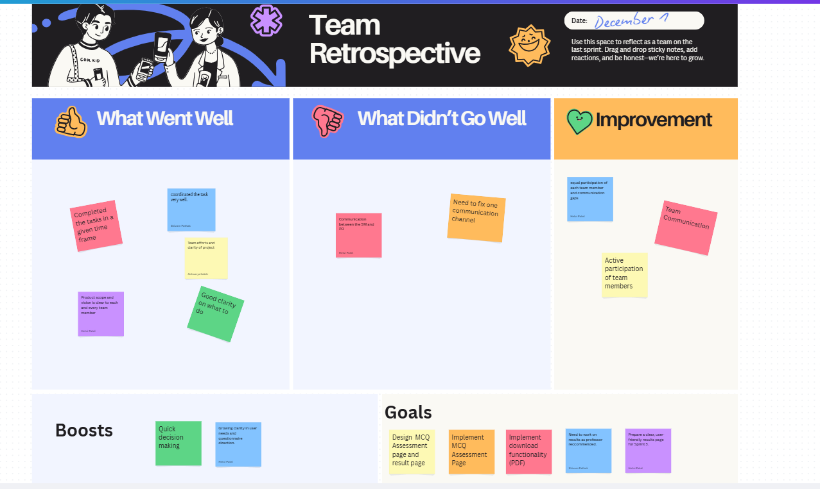
Appendix
A. Meeting Attendance Proof
Images/screenshots from meetings held on:
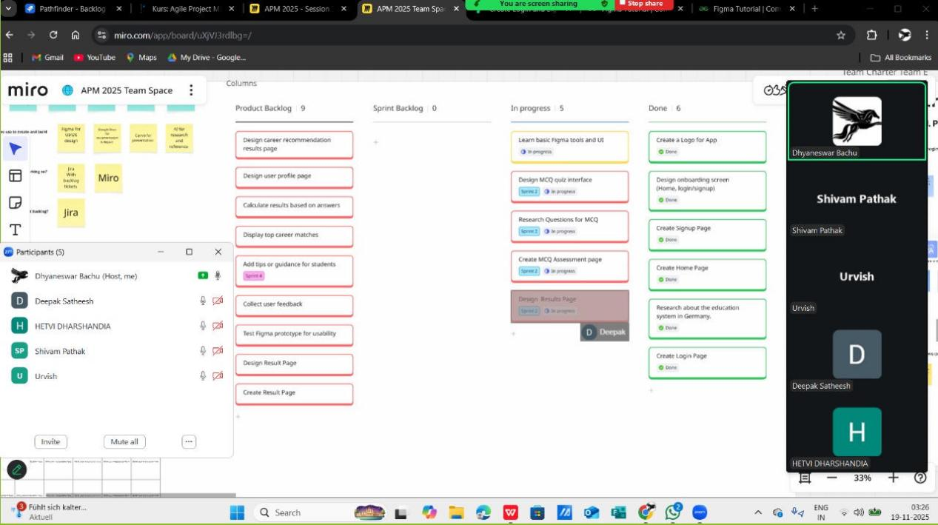

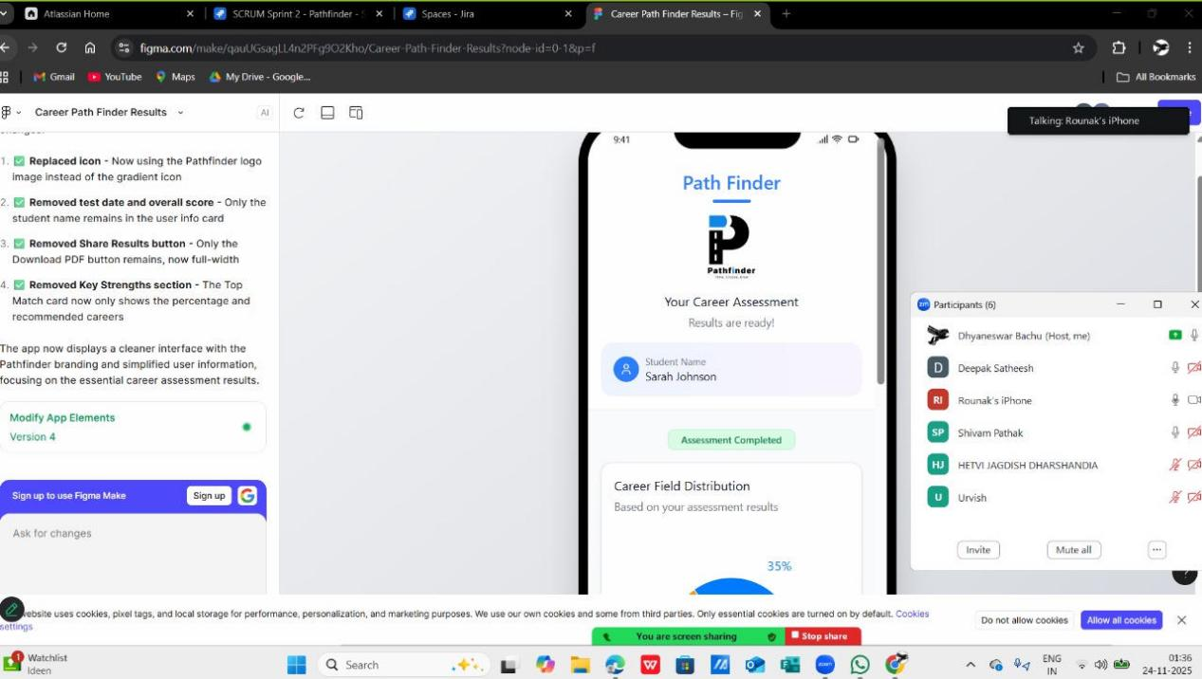

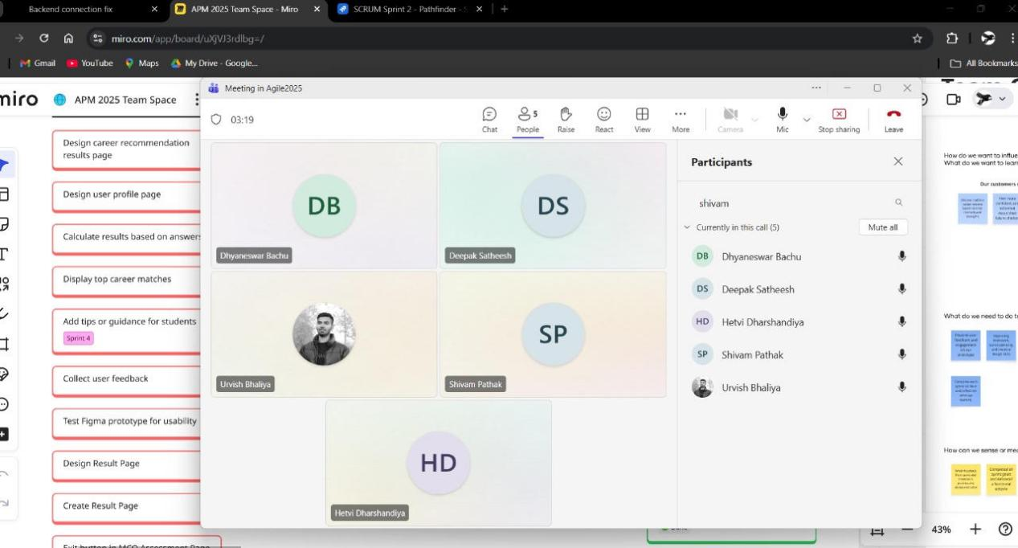

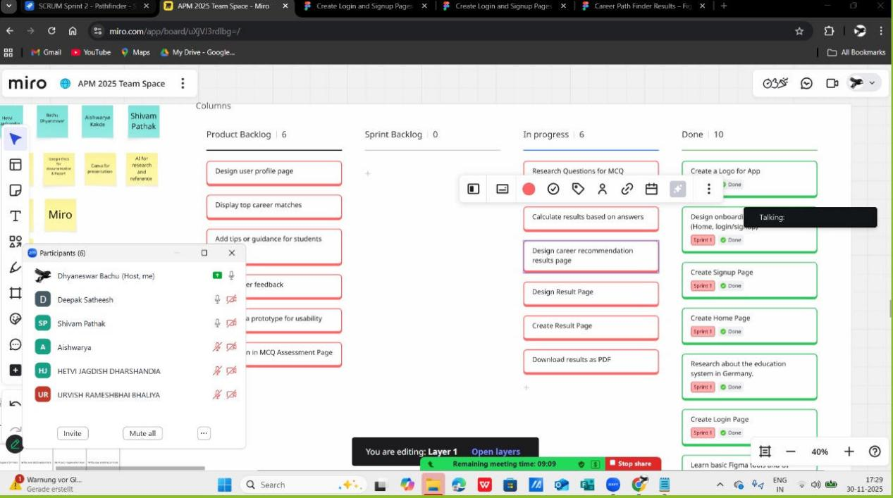
B.Sprint Artifacts
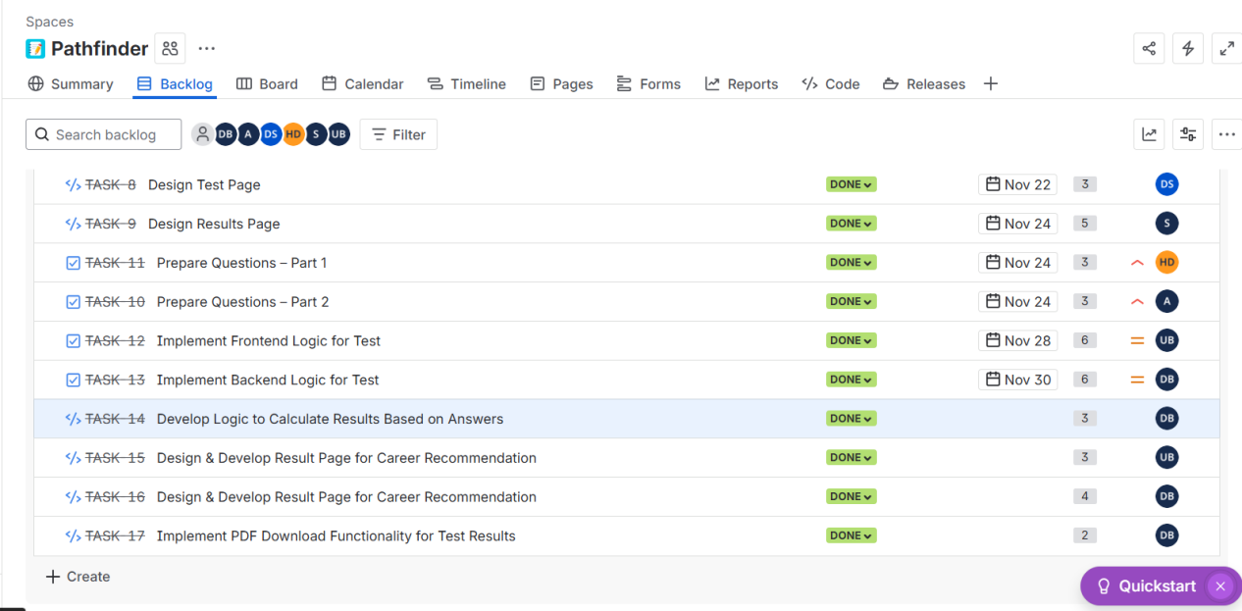
- UI Designs and Final Outputs
MCQ Assessment Page in WebView
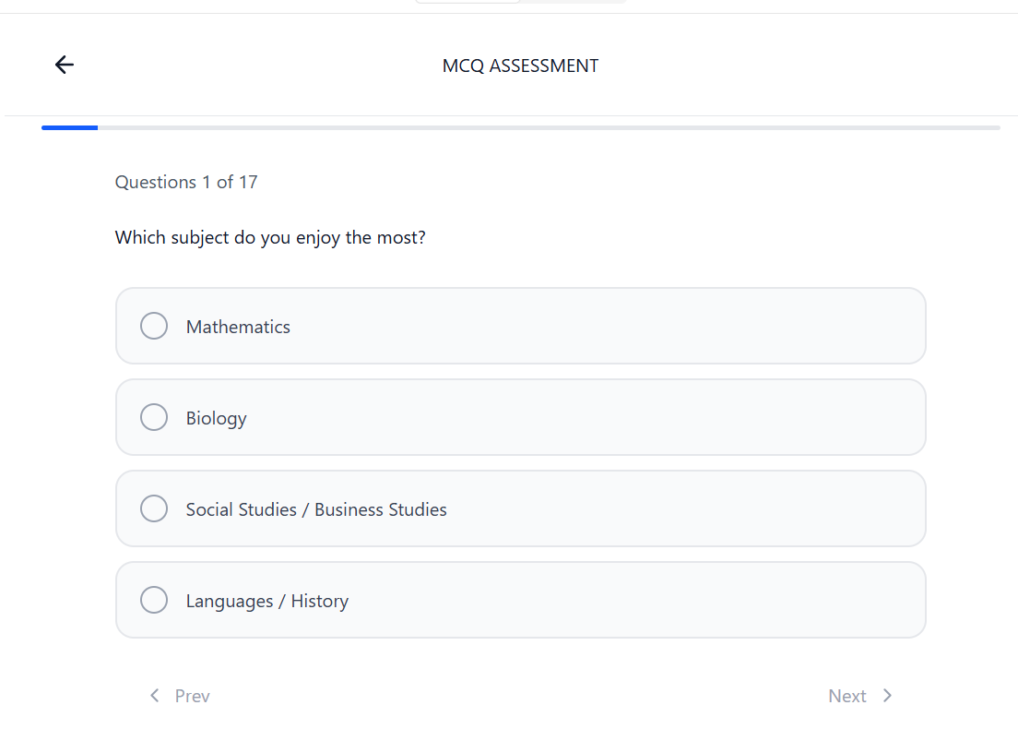
Results Page in Web View:
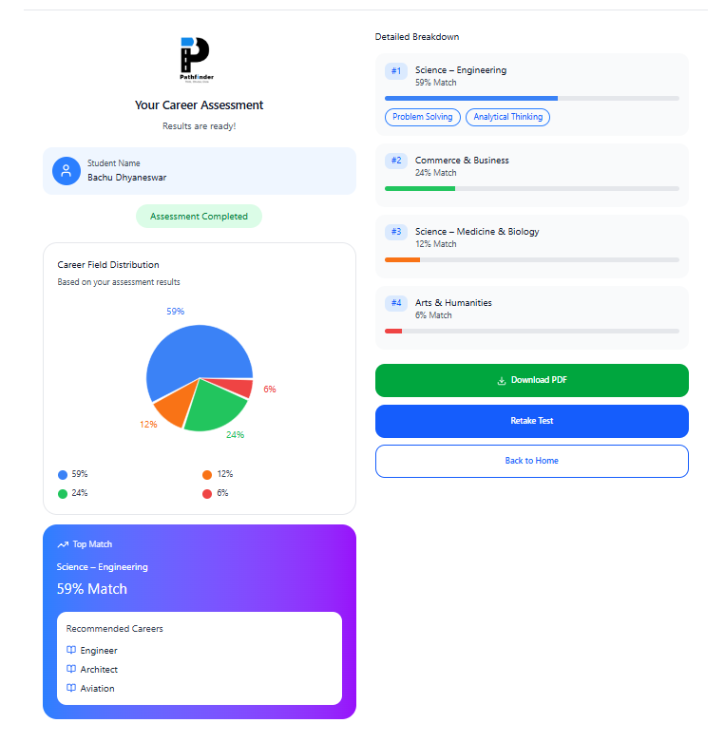

Download PDF:
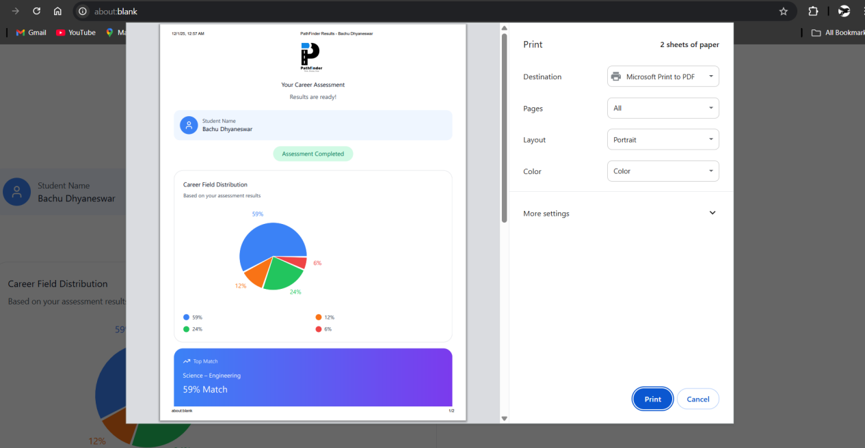

MCQ Assessment Page in Mobile View:
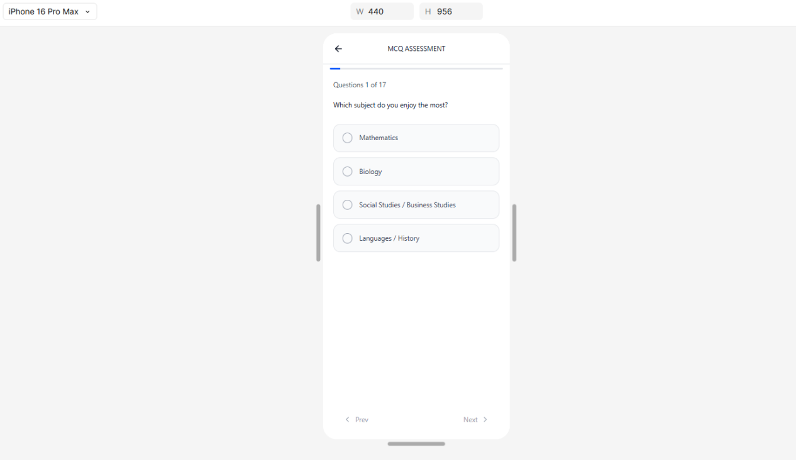

Results Page Mobile View:
